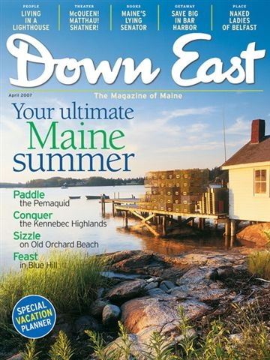

My Blue Heaven
By Maria Padian
Down East Magazine, April 2007

Our first trip to Blue Hill sprang from sheer desperation.
There we were, thirty-somethings with toddlers, each month counting on one hand the number of uninterrupted nights of sleep we logged. We shuttled from work to home in a haze familiar to many young parents. We rarely went out on a “date.” And we absolutely, never, in our wildest dreams, even considered taking the canoe out for a paddle.
Ironically, the canoe is what brought us to Maine to begin with.
Pre-kids, my husband and I were urban professionals who fled the city each weekend in search of white water, car-topping our Old Town Tripper and driving for hours along packed highways in search of navigable rivers. One summer, at the urging of Maine friends, we headed north to paddle the West Branch of the Penobscot. You can imagine what followed.
We fell in love. We fell in love with the near-blind moose munching river weeds as we drifted silently past them. We fell in love with the loon’s cry at night, the osprey diving for trout, and the view of Mount Katahdin as we paddled across Chesuncook Lake. We were sold on the way life should be, and within two years relocated to Maine and started a family.
What a rude awakening it was when I realized that life for a southern Maine mother of two isn’t all that different from life for a mother of two in New Jersey. Our young children’s needs took precedence over everything, and instead of canoeing wild rivers we spent weekends at playgrounds. Instead of winter trekking on cross-country skis through Baxter State Park we made snowmen in the front yard. It was, to be frank, a duller, colder and darker life than anticipated.
“You need a break,” advised the friends who’d lured us here. They offered to babysit, and presented us with a gift certificate for two nights at the Blue Hill Farm Inn. We jumped … no, leapt … at the chance.
It was just what the doctor ordered. Tucked into the eastern shore of a craggy peninsula that juts into Penobscot Bay, Blue Hill has no McDonald’s, Chucky Cheese’s or kid-friendly beaches. Activities include bookstore browsing and gallery gazing. Most restaurants lack children’s booster seats and the big entertainment is the summer chamber music festival at Kneisel Hall. In other words, Blue Hill is a very grown up place. With one important piece de resistance: an authentic French bistro.
We stumbled, literally, into this oasis on Blue Hill’s Main Street our first day. As we read the menu posted outside an unassuming white saltbox house, a deeply-tanned man clad in Bermuda shorts and a button-downed shirt greeted us.
“Two?” he said, his accent unabashedly French. “I put you on the lawn?” Behind him we could see people dining in a glorious outdoor garden. A terraced expanse of green dotted with Adirondack chairs sloped down to Blue Hill Bay. Khaki-clad waiters scurried from the kitchen to the tables to the lawn chairs, bearing carafes of wine, leafy salads, and decadent pastries. Yes, we agreed, wooden chairs with water views would be just fine.
Somewhere between the pate and the pureed vegetable soup, the knots between our shoulders relaxed. Around the second glass of Chardonnay we discovered how fascinating it is to watch sandpipers race along the shore at low tide. And by the time we’d finished our croque monsieur sandwiches and were contemplating the wild Maine blueberry tarte, our restoration was complete. This, too, was the way life should be. An improbable microclimate where balloon flowers, foxgloves and hostas bloomed simultaneously, sea birds swooped for our entertainment, and someone served us great food while we watched the tide roll in.
We’ve returned to that afternoon many times over, in countless different places throughout Maine: popovers and tea on the lawn at Acadia’s Jordan Pond House, a dinner picnic at Popham Beach, chowder and fresh haddock on the dock at Five Islands. So have our kids, who no longer require booster seats and have learned to paddle the canoe. We thank our lucky stars that before we pulled up stakes and ran our friends helped us figure out that Maine’s natural beauty isn’t the sole property of the extreme sports set. It’s there for anyone willing to slow down, break bread and take in the view.

